**WORD SEARCH – The respiratory system**

Find the vocabulary in the wordsearch and make a drawing of each word.

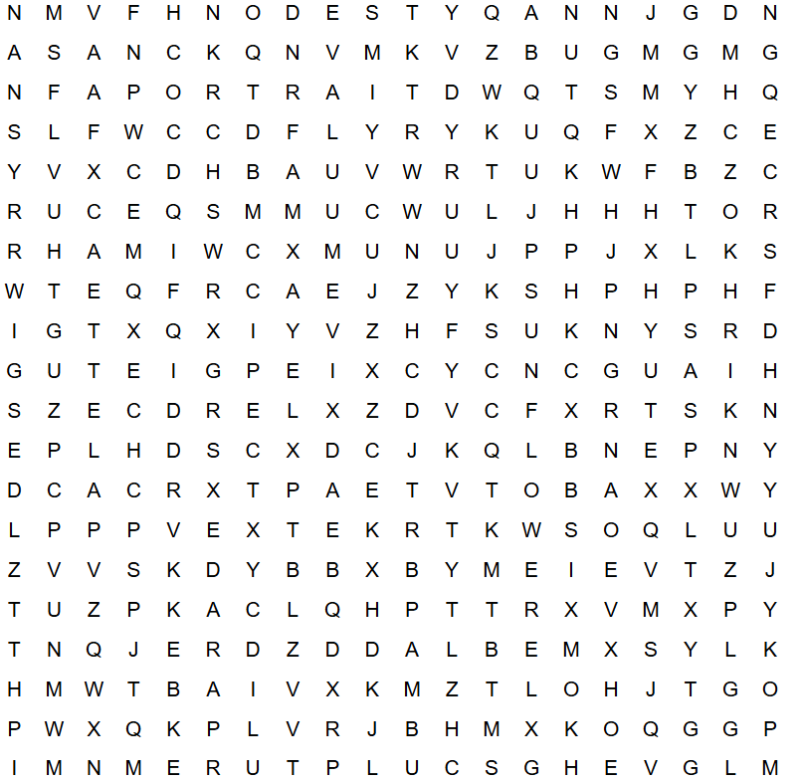

|  |  |  |  |
| --- | --- | --- | --- |
|  |  |  |  |
| XXXXXXXXX | XXXXXXXXX | XXXXXXXXX | XXXXXXXXX |
|  |  |  |  |
| XXXXXXXXX | XXXXXXXXX | XXXXXXXXX |  |